AGENDA
McKinney Legacy Neighborhood Association
Board Meeting #26
01/12/2026 @ 6:00 PM
Old Settlers Recreation Center
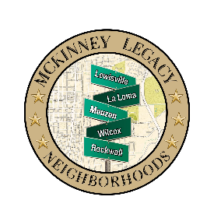

Call to Order

Roll Call

Minutes of MLNA Meeting, November 10, 2025

Motion to approve

Introduction of Guest Presenter
Presentation: Streetlights Residential
Q & A

Reports

Treasurer's Report

Secretary's Report

Marketing Report

President's Report

Public Comments on non-agenda items

Board Member Comments

Adjourn

(No Executive Session)

